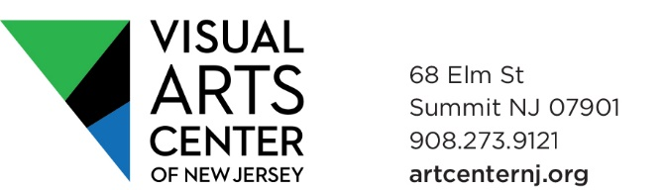

New Faculty Application Information

Contact Information
Name | Click here to enter text.
Street Address | Click here to enter text.
City - State - Zip Code | Click here to enter text.
Home Phone | Click here to enter text.
Cell Phone | Click here to enter text.
E-Mail | Click here to enter text.
Website (if applicable) | Click here to enter text.

Availability

During which hours are you available to teach?
☐Weekday mornings | ☐Weekend mornings
☐Weekday afternoons | ☐Weekend afternoons
☐Weekday evenings

Mediums/Subjects

Tell us in which areas you are interested teaching (check all that apply)
☐Ceramics |  |  | ☐Digital Media/Photography
☐Drawing & Painting |  |  | ☐Fiber
☐Jewelry |  |  | ☐Printmaking
☐Sculpture |  |  | ☐Professional Development
☐ Other ____________________________

Age Range
Please tell us what age range(s) you would like to teach (check all that apply)
☐Adults | ☐Teens
☐Kids | ☐Pre K

Previous Teaching Experience
Click here to enter text.

Education

Please list institutions, degrees/diplomas, etc.
Click here to enter text.

Biography

Please provide us with a brief biography of your professional experience (exhibitions, awards, etc.)
Click here to enter text.

Agreement and Signature

By submitting this application, I affirm that the facts set forth in it are true and complete. I understand that if I am accepted as an instructor, any false statements, or other misrepresentations made by me on this application may result in my immediate dismissal.
Name | Click here to enter text.
Date | Click here to enter text.

Our Policy

It is the policy of this organization to provide equal opportunities without regard to race, color, religion, national origin, gender, sexual preference, age, or disability.

FORM COMPLETION

On completing this form, please rename & save it as: LASTNAME, FIRSTINITIAL
Email completed forms to proposals@artcenternj.org
Please attach any JPEG images of yours, or your students’ work along with this form.

Thank you for completing this application form and for your interest in teaching for us!

